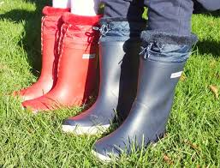

**Maths -Y2**

Week 1: Time

Week 2: Position and direction

Week 3: Shape

Week 4: Add and subtract to 100 (1)

Week 5: Add and subtract to 100 (1)

Week 6: Money

Week 7: Time

**Language Class**

**Summer 2**

**Forest School (Monday)**

All pupils to arrive in leggings / jogging trousers, school polo shirt and jumper plus a waterproof coat (with hood) and wellies in a bag to change into. Warm hat and gloves optional in cooler weather.

Week 1: Stranger danger

Week 2: Following directions.

Week 3: Shape weaving (1)

Week 4: Shape weaving (2)

Week 5: Sunflower art

Week 6: Shadows and the sun

Week 7: End of term picnic

**Speech and Language**

All of the children have individual speech and language targets determined by the Mrs Williams, speech therapist. Each child will have focus therapy sessions Tuesday – Friday where they will work specifically on their targets.

Each day there will be 30 minutes of whole class speech and language activities, either as 2 x 15 mins or as one long session. Whole class activities include working on;

* Listening to, giving or following instructions
* Building vocabulary
* Building sentences for speech
* Turn taking and the conventions of conversation
* Pronouns, prepositions, verbs



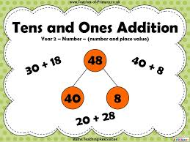

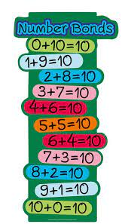

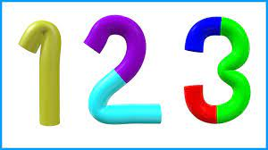



**Writing**

The children in Language Class will complete all of their writing as part of the Read, Write, Inc programme. This is a daily programme that involves phonics, writing and spelling of words appropriate to the stage of learning.

Handwriting, using a cursive writing style is also an essential part of daily writing activities.

**Reading**

Week 1: People who help us – Teacher

*To explain clearly their understanding of what is read to them.*

Week 2: Firefighters (non-fiction)

*To explain clearly their understanding of what is read to them*

Week 3: The 3 little pigs

*To listen attentively to a playscript beyond a level which they can read independently.*

Week 4: Life cycle of a Sunflower

*To explain clearly their understanding of what is read to them*

Week 5: Camille and the sunflowers

*To explain clearly their understanding of what is read to them*

Week 6: Fidgety fish

*To predict what might happen from what has been read so far.*

Week 7: The Lighthouse Keeper’s Lunch

*To make inferences from the text based on what is said and done.*

**Maths -Reception**

Week 1: Taking away

Week 2: Doubling, odd and even

Week 3: sharing and grouping

Week 4: Spatial reasoning and pattern (1)

Week 5: Spatial reasoning and pattern (2)

Week 6:Time

Week 7: Consolidation of pattern

**Maths -Y1**

Week 1: Time

Week 2: Position and direction

Week 3: Assessment week

Week 4: Place value within 100 (1)

Week 5: Place value within 100 (2)

Week 6: Money

Week 7: Time