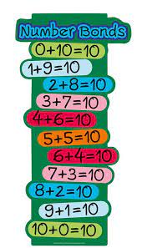



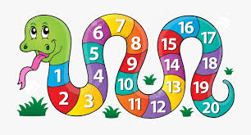

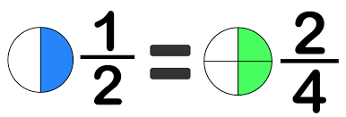

**Maths -Y1**

Week 1: Multiplication and division (1)

Week 2: Multiplication and division (2)

Week 3: Multiplication and division (3)

Week 4: Fractions (1)

Week 5: Fractions (2)

**Maths -Y2**

Week 1: Multiplication and division (1)

Week 2: Length and height

Week 3: Position and direction

Week 4: Fractions

Week 5: SATS week

**Speech and Language**

All of the children have individual speech and language targets determined by the Mrs Williams, speech therapist. Each child will have focus therapy sessions Tuesday – Friday where they will work specifically on their targets.

Each day there will be 30 minutes of whole class speech and language activities, either as 2 x 15 mins or as one long session. Whole class activities include working on;

* Listening to, giving or following instructions
* Building vocabulary
* Building sentences for speech
* Turn taking and the conventions of conversation
* Pronouns, prepositions, verbs



**Language Class**

**Summer 1**



**Forest School (Monday)**

All pupils to arrive in leggings / jogging trousers, school polo shirt and jumper plus a waterproof coat (with hood) and wellies in a bag to change into. Warm hat and gloves optional in cooler weather.

Week 1: Be a postman!

Week 2: *Bank holiday – no forest school*

Week 3: Visit to the post office

Week 4: Shape frames

Week 5: Showtime!



**Writing**

The children in Language Class will complete all of their writing as part of the Read, Write, Inc programme. This is a daily programme that involves phonics, writing and spelling of words appropriate to the stage of learning.

Handwriting, using a cursive writing style is also an essential part of daily writing activities.

**Reading**

Week 1: The Postman (non-fiction text)

*To discuss the significance of the title and events*

Week 2: The Jolly Pocket Postman

*To make inferences from the text based on what is said and done.*

Week 3: The train Ride

*To appreciate rhymes and poems, and to recite some by heart.*

Week 4: Doctor Foster

*To appreciate rhymes and poems, and to recite some by heart*.

Week 5: Please Mrs Butler

*To appreciate rhymes and poems, and to recite some by heart.*

**Maths -Reception**

Week 1: Counting to 20 and beyond (1)

Week 2: Counting to 20 and beyond (2)

Week 3: Match, rotate and manipulate shapes

Week 4: Add and subtract (1)

Week 5: Add and subtract (2)