

Happy, successful, curious communicators

**Speech and Language**

All of the children have individual speech and language targets determined by the Mrs Williams, speech therapist. Each child will have focus therapy sessions Tuesday – Friday where they will work specifically on their targets.

Each day there will be 30 minutes of whole class speech and language activities, either as 2 x 15 mins or as one long session. Whole class activities include working on;

* Listening to, giving or following instructions
* Building vocabulary
* Building sentences for speech
* Turn taking and the conventions of conversation
* Pronouns, prepositions, verbs





**Language Class**

**Spring 2**

**Phonics**

All children in the Language Class have their phonics delivered through the Read, Write Inc. scheme. This involves learning 3 sets of sounds and reading words, simple sentences and stories linked to these. Every pupil is reassessed half termly and moved through the scheme accordingly. Individual reading books are also linked to individual ability.

**Writing**

The children in Language Class will complete all of their writing as part of the Read, Write, Inc programme. This is a daily programme that involves phonics, writing and spelling of words appropriate to the stage of learning.

Handwriting, using a cursive writing style is also an essential part of daily writing activities.

**Maths -Y1 / 2**

Week 8: Place value to 50

Week 9: 2x / 5x tables

Week 10: Assessment week

Week 11: Time

Week 12: Weight

Week 13: Volume



**Forest School (Monday)**

All pupils to arrive in leggings / jogging trousers, school polo shirt and jumper plus a waterproof coat (with hood) and wellies in a bag to change into. Warm hat and gloves optional in cooler weather.

Week 8: Senses

Week 9: Planting seeds

Week 10: Walk to Dothill ponds

Week 11: Dragonflies and butterflies.

Week 12: Morrisons visit

Week 13: Easter

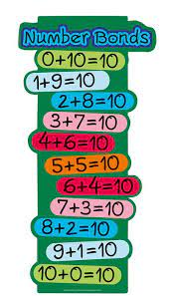

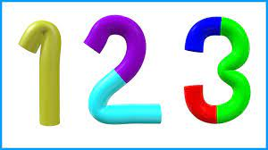



**Reading**

Week 8: Let’s look at Growing *- To discuss word meanings and link new meanings to words already known.*

Week 9: Spring in Brambly Hedge *-To clearly explain their understanding of what is read to them by participating in discussion, taking turns and listening to what others say.*

Week 10: Assessment week

Week 11: The Hungry Caterpillar - *To discuss the significance of the title and events.*

Week 12: The very lazy ladybird - *To make inferences from the text based on what is said and done.*

Week 13: - Easter stories - *To predict what might happen from what has been read so far.*

**Maths -Reception**

Week 8: Numbers to 10

Week 9: Adding and subtracting within 10

Week 10: Adding and subtracting within 10

Week 11: Time

Week 12: Weight

Week 13: Volume